Name
10th Magnitude [Company address]
Identity Discovery
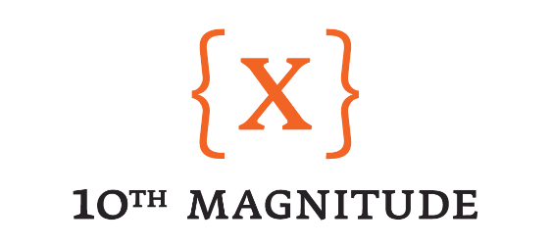

Identity Discovery – Overview

Description

The goal of Identity discovery is to understand the topology of your current identity deployment and how to extend that into Azure. This session also will look in how we can leverage as a security layer and simplify how access is handled in the cloud.

Approach

During this design session we are going to be working to get an overview of the identity landscape and how your organization leverges identity. We will be asking questions to gain a better understanding of the identity deployment, overall IAM process, and the topology deployed.

Goal

The goal of this session is to understand how we need to accommodate the identity layer within the Azure deployment. We will also look at ways in which we can simplify access and RBAC within Azure, both of which are influenced by identity.

Identity Discovery – Questions

The following questions will guide us in understanding the identity structure for your Azure deployment. Feel free to answer these questions ahead of the Cloud Design Sessions if possible. As part of the design sessions, we will ensure that these questions are answered in order to progress to the design and build phases of the project.

- Existing ADDS Forest/Domain topology and details
  - Single root transitive forest & domain
  - HPINC.com / HP -netbios
  - 2016 functional level
  - ADDNS
- Existing IdM processes and tooling summary - provisioning, SSO, MFA, cloud identity services, PIM/PAM
  - OKTA
  - Duo
- Current Identity and Group Synchronization practices (AAD Sync)
  - AAD Sync
- Groups - ADDS vs. AAD groups - Team and Access group approach within organization
  - ADDS groups primary on premise
    - Not all synched via AAD Sync to Azure AD
  - AAD groups used cloud only per application requirements.

